Web Programming
Dr. Barker
Adam Carling
9/29/26

I have decided to create a Wikipedia style recipe website. The concept is that each recipe will have hyperlinks to other pages explaining concepts and ingredients to the user. I have started with one recipe, Mac n Cheese, and will add other pages based on their connection to this first recipe. For now, I plan to create another 5 pages centered around variation recipes, substitute ingredients, ingredient pages.
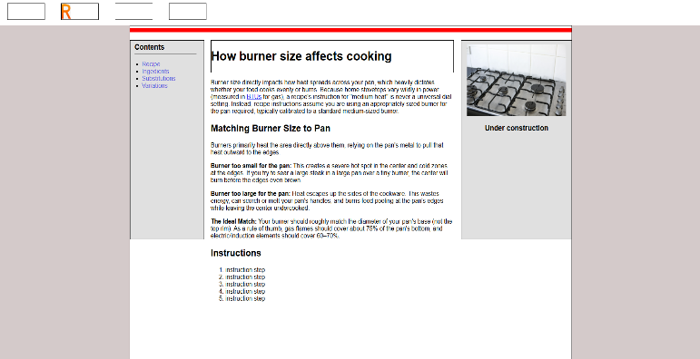
The pages I have added so far are:
- Index (populated by a TODO list
- The template page
- Roux
- Mac and Cheese Recipe
- Stove Top Heat Levels
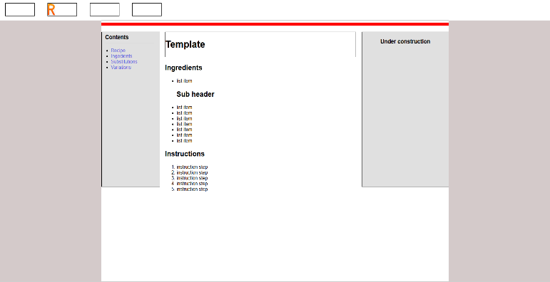
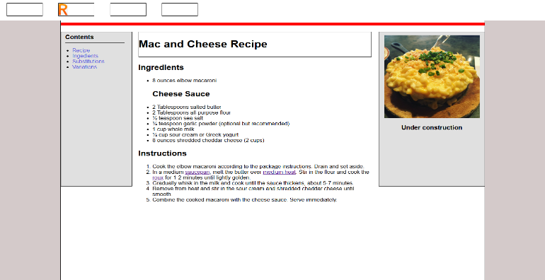
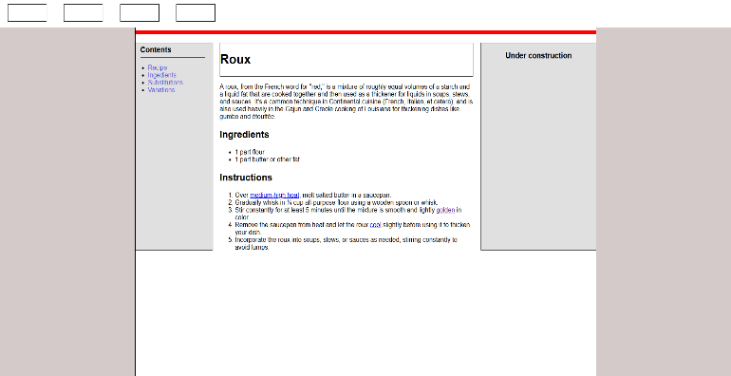
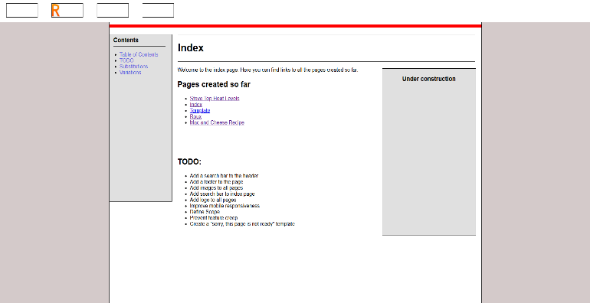

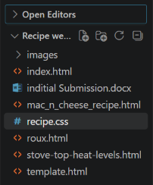
Files currently in use

